**

**

No. KFD/700/2024/MIS 30-09-2024

**QUOTATION NOTICE**

Sealed competitive quotations are invited from the Manufactures/Dealers on or before **3pm** on **25/10/2024** for the Supply and installation of ***Biometric Punching Machine*** with following specifications for various offices of KERAFD throughout Kerala. (Approximate 06 Nos.)

***Specification Required for Biometric punching machine:***

* Multi-Biometric terminal compatible with ADMS/WDMS servers with

Latest Firmware.

* Terminals must have the latest face identification Algorithm
* Infrared active illuminant technology to enable user identification in poorly lit environment.
* Terminals with push data technology to support the transfer the real time log data to central server over internet.
* Terminal must support Face, card, Fingerprint, password Identifications modes or combination of these.
* Terminal must have a minimum capacity to hold 500 face templates, 500 fingerprint template and 500 RF cards.
* Matching and identification speed with full load of 500 templates must be less than 1 second.
* Provision to register identification template at central server and to transfer/upload templates to biometric terminals at remote location.
* Grouping of terminals at a location and auto sync the templates between these terminals.
* Provision for integrating access control with electric lock for doors
* Communicating via Wi-Fi, TCP/IP and USB (Host and client)
* Terminal settings through 3inch touch screen with T9 Input.
* Terminal management from central server such as firmware upgrade, rebooting terminals, clear data logs, delete selected templates, monitor terminal online offline status
* Flexible database interface with MSSql Server, MySql to provide data to the HR modules.

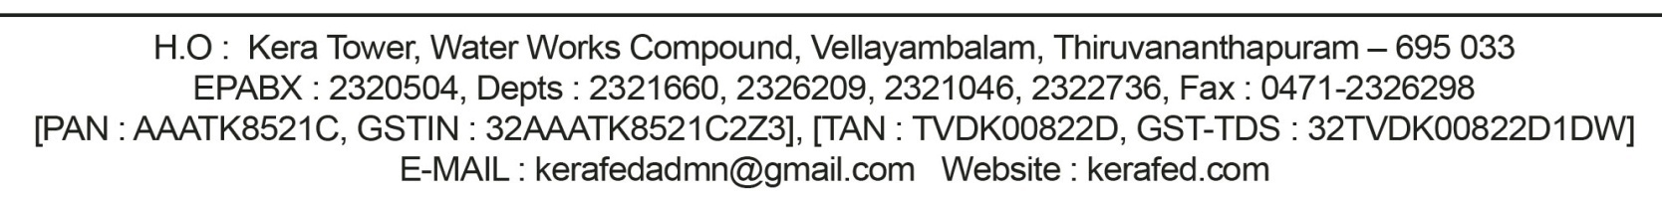

***Terms and conditions:***

* 1. The rate should be quoted including all taxes, levies,duties etc.
  2. The price including supply, installation, testing, training, commissioning, transportation, loading and unloading charges.
  3. Necessary warranty certificates should be furnished along with the supply of items.
  4. Manufacturer’s Authorization Form(MAF) in original should be submitted
  5. Data Sheet of quoted item from OEM with specification sought marked or highlighted
  6. Compliance statement mentioning the specification offered against demand in tender, variation if any and cross reference to the attached data sheet.
  7. Period of Supply:Within15days after confirm order.
  8. Time of opening quotations–4.00pm on the same day.

Please submit your quotation in a sealed envelope marked "Quotation for BIOMETRIC PUNCHING MACHINE" to MANAGING DIRECTOR,KERAFED, KERA TOWER, WATER AUTHORITY COMPLEX ,VELLAYAMBALAM,TRIVANDRUM-33 on or before 15.10.2024. Also note that all the undersigned reserves the right to accept or reject any or all quotations without providing any reason. Additional details if any required and the other terms and conditions can be had from the office of the undersigned.

Sd/-

**Managing Director**